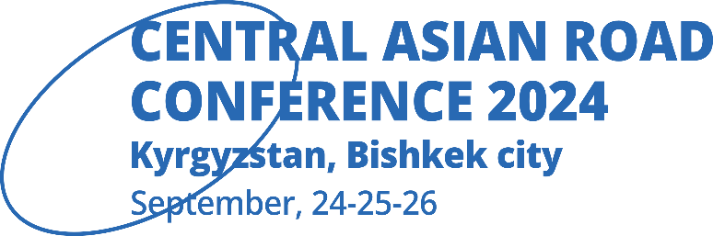

**HOTEL ACCOMODATION in**

**SHERATON BISHKEK CITY and RAMADA by WYNDHAM Bishkek Centre**

**DURING CONFERENCE CARC 2024**

**SPECIAL PRICES WITH PROMOTIONAL CODE**



Sheraton Bishkek city - **sales@sheratonbishkek.com** with promotional code: **CARC2024**

Ramada by Wyndham Bishkek Center - [**reservation@ramadabishkek.com**](mailto:reservation@ramadabishkek.com) with promotional code: **CARC2024**

**Best regards,**

**CARC 2024**

**Scientific and Educational Center InDorTech, LLP**

**1b Kasteev Str., 050010, Almaty City, Kazakhstan**

**Tel: +7 702 5444437 Rassim (rus,eng)**

**Tel: +7 705 9121835 Olga (rus)**

**Tel: +7 705 440 99 04 Olesya (rus)**

**Tel: +7 777 125 5333 Manizha - only booth questions (rus,eng)**

[https://carc-indortech.com](https://carc-indortech.com/)